Switch Layer 3
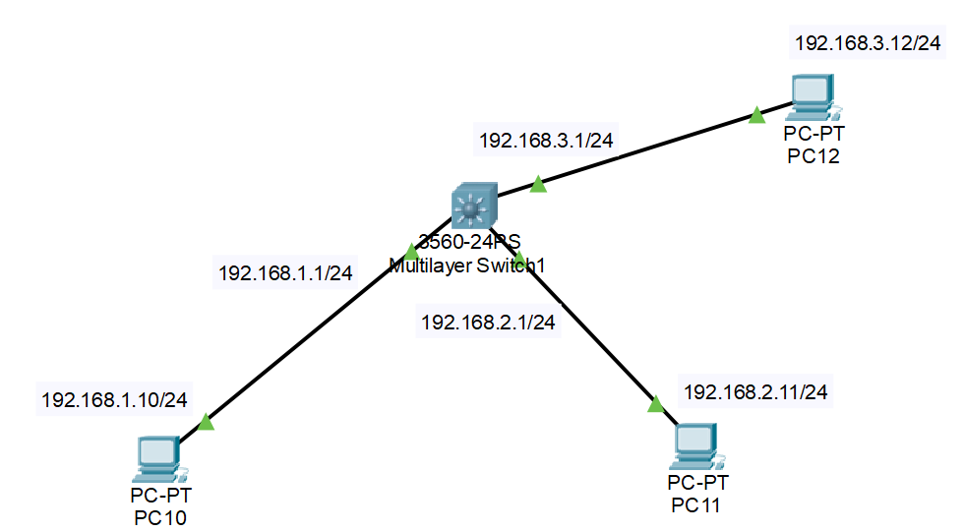
Configurazione Switch1
Switch(config)#hostname Sw1
Porta FastEthernet 0/1
Sw1(config)#interface fastEthernet 0/1
Sw1(config-if)#ip address 192.168.1.1 255.255.255.0
Sw1(config-if)#no switchport
Sw1(config-if)#no shutdown
Porta FastEthernet 0/2
Sw1(config)#interface fastEthernet 0/2
Sw1(config-if)#no switchport
Sw1(config-if)#ip address 192.168.2.1 255.255.255.0
Sw1(config-if)#no shutdown
Porta FastEthernet 0/3
Sw1(config)#interface fastEthernet 0/3
Sw1(config-if)#no switchport
Sw1(config-if)#ip address 192.168.3.1 255.255.255.0
Sw1(config-if)#no shutdown
Abilitare il routing
Sw1(config-if)#exit
Sw1(config)#ip routing

