Configurazione IPv6 - due reti tramite router
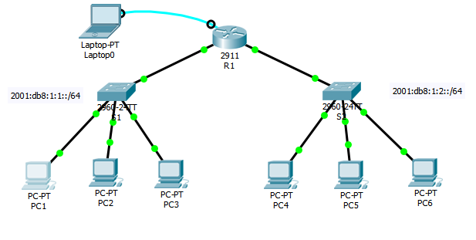Tabella degli indirizzi
Device | Interface | IPv6 Address/Prefix | Default Gateway
R1 | G0/0 | 2001:DB8:1:1::1/64 | N/A
R1 | G0/1 | 2001:DB8:1:2::1/64 | N/A
R1 | Link-local | FE80::1 | N/A
PC1 | NIC | 2001:DB8:1:1::2/64 | FE80::1
PC2 | NIC | 2001:DB8:1:1::3/64 | FE80::1
PC3 | NIC | 2001:DB8:1:1::4/64 | FE80::1
PC4 | NIC | 2001:DB8:1:2::2/64 | FE80::1
PC5 | NIC | 2001:DB8:1:2::3/64 | FE80::1
PC6 | NIC | 2001:DB8:1:2::4/64 | FE80::1

Abilitare il router a trasmettere pacchetti IPv6
R1(config)#ipv6 unicast-routing
Questo comando serve per abilitare il router all’utilizzo degli indirizzi IPv6.
Configurare IPv6 addressing su GigabitEthernet0/0.
R1(config)#interface gigabitEthernet 0/0
R1(config-if)#ipv6 address 2001:DB8:1:1::1/64
R1(config-if)#ipv6 address FE80::1 link-local
R1(config-if)#no shutdown

Configurare IPv6 addressing su GigabitEthernet0/0.
R1(config)#interface gigabitEthernet 0/1
R1(config-if)#ipv6 address 2001:DB8:1:2::1/64
R1(config-if)#ipv6 address FE80::1 link-local
R1(config-if)#no shutdown
Configurare IPv6 addressing su PC1.
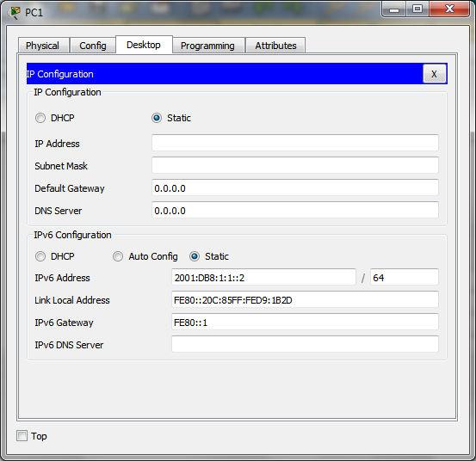
Configurare IPv6 addressing su PC2, PC3, PC4, PC5, PC6.

Verificare la connettività
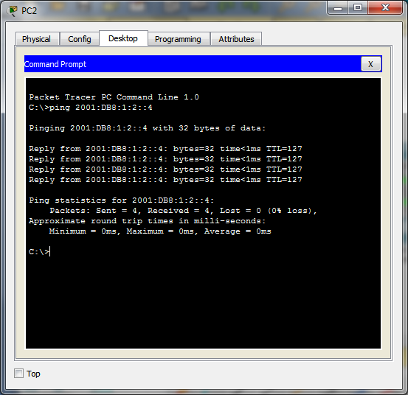
Visualizzazione tabella NDP
netsh interface ipv6 show neighbors

